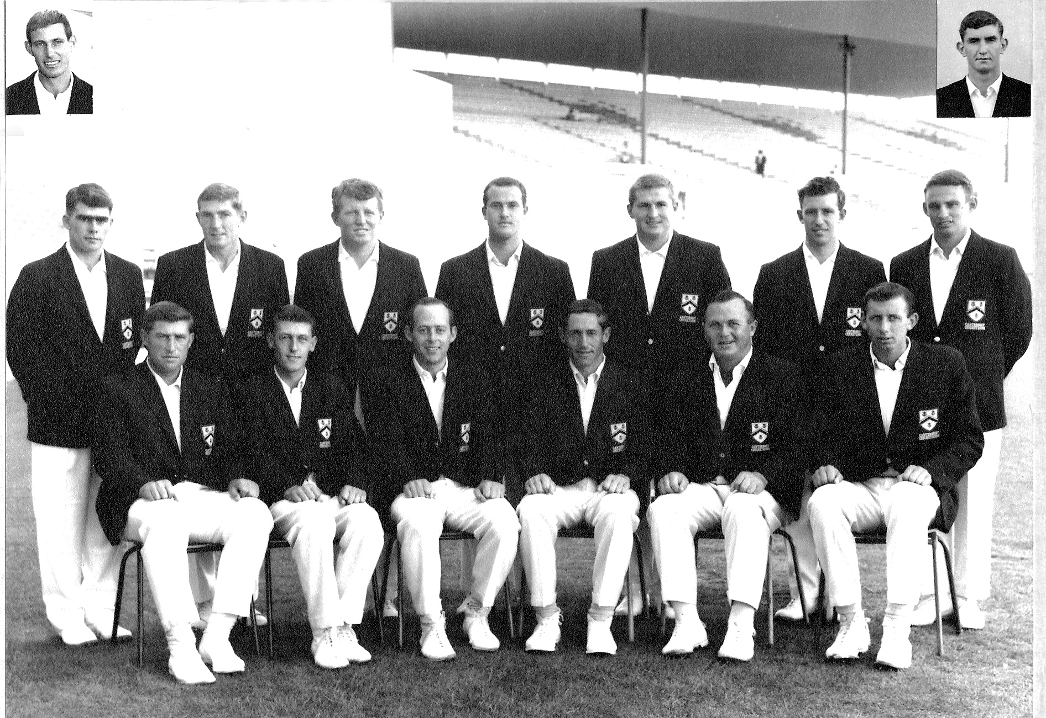

**Canterbury Representative Team 1966/67**

**Back Row:** BP Isherwood, KI Ferries, CJ Stevens, JM McIntyre, ML Ryan, JW Burtt, CL Bull

**Front Row:** RC Motz, JT Ward, BF Hastings, GT Dowling, K Thomson, BR Taylor

**Inset:** CL Broad, B Andrews